ST. VINCENT’S CATHOLIC PRIMARY SCHOOL
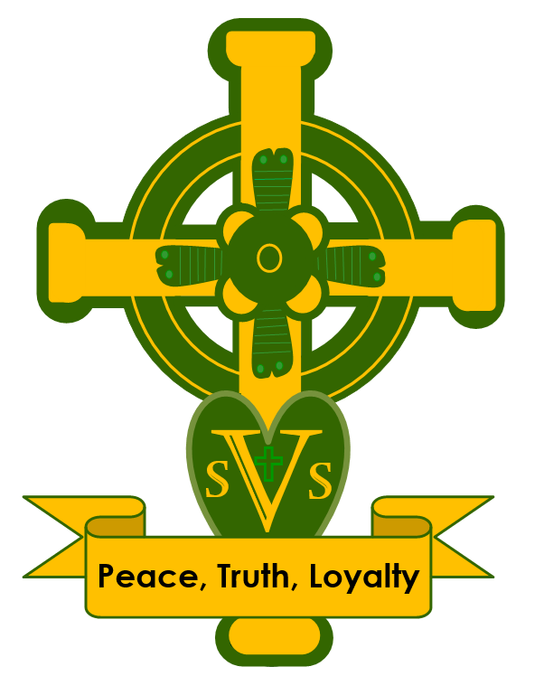

SCIENCE POLICY

Date reviewed: July 2025
Date of next review: July 2026


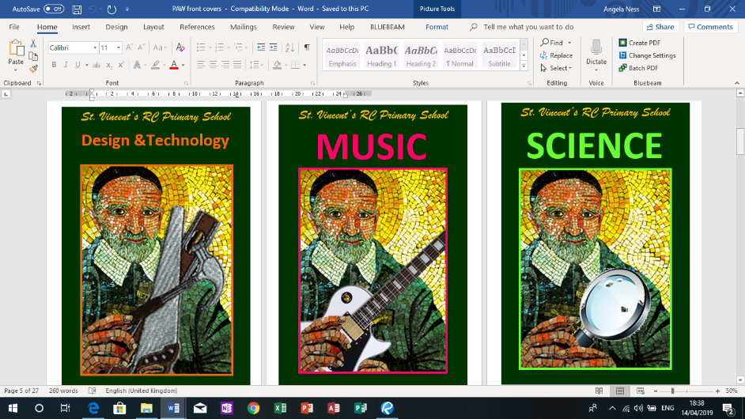
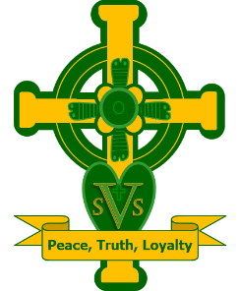

Science Policy

CONTENTS
- Mission Statement 2
  - Aims and Objectives 2
- Approaches to Teaching and Learning 2
  - Teaching and learning styles 2
- Resources 2
- Learning Environment 2
- Planning 2
- Assessment: 3
- Cross Curricular Opportunities 3
  - Reading, writing, communication, maths and ICT 3
  - Spiritual, Moral, Social and Cultural 3
- Enhancing the Curriculum 3
- Inclusion: 3
  - Special Educational Needs and Disabilities 3
  - Gifted and Talented 4
- Health and Safety and Safeguarding 4
- Roles and Responsibilities 4
- Policy Review 4
This policy should be read in conjunction with the Teaching and Learning Policy, any related subject policies and the following:

Assessment Policy Behaviour Policy
Equality and Community Cohesion Policy
Health and Safety Policy
Homework Policy
Safeguarding and Child Protection Policy Special Educational Needs and Disability Policy E-Safety Handbook
Home School Agreement Marking Policy

Other documents that support the teaching and learning of Science:
Science Resource Books (some are kept centrally in the science resources cupboard and others by individual year groups)
Hamilton Trust topic plans
Internet Resources
2014 National Curriculum
Science Network schemes of work (network run by consultant Phil Watkins).

Throughout this policy ‘parents’ denotes those with parental responsibility.

Mission Statement
At St. Vincent’s, we believe that science is a body of knowledge built up through experimental testing of ideas. Science is also methodology, a practical way of finding reliable answers to questions we may ask about the world around us. Science in our school is about developing children’s ideas and ways of working that enable them to make sense of the world in which they live through investigation, as well as using and applying process skills. Scientific experimentation provides pupils with the opportunity to methodically investigate and test their ideas, to critically analyse their results and to effectively communicate the knowledge they have gained.

Aims and Objectives
We aim to provide pupils with the opportunity to:
- develop their sense of curiosity which will encourage a positive attitude of enquiry about familiar and unfamiliar aspects of their world;
- develop a set of positive attitudes which promote a scientific way of thinking which includes open-mindedness, perseverance, creativity, objectivity, and a recognition of the importance of teamwork;
- develop their understanding of the nature of working scientifically which involves clear planning, detailed observation, the development and testing of hypothesis, prediction, the design of fair and controlled testing, the reliability of results, peer review and the drawing of meaningful conclusions through critical reasoning and the evaluation of evidence;
- become effective communicators of their scientific ideas and to question, in the appropriate manner, the scientific planning/investigation outcomes of themselves and their peers;
- develop knowledge and understanding of important scientific ideas, processes and skills and relate these to everyday experiences.

Teaching and Learning

Teaching and learning styles
In addition to approaches referred to in the Teaching and Learning Policy, science teaching also includes opportunities for children to:
- critically examine the relevance of their and other pupils’ investigations;
- investigate, observe, record and make meaningful conclusions from their scientific investigations.

Resources
Pupils use of a variety of scientific materials and equipment. Science Resource are located in the Science cupboard, located in the school hall.

Learning Environment
Please refer to the Teaching and Learning Policy

Planning
In the Early Years Foundation Stage, objectives linking to science are taught through ‘Understanding the World’. In KS1 and KS2, science is taught each week as a discrete subject, with additional cross-curricular opportunities through class topics.

The school follows the National Curriculum. Generally, one unit is taught in each half-term. Where possible, science is linked to class topics allowing children to contextualise their learning. Teachers are expected to adapt and modify their planning to suit their children’s interests within the unit and level of understanding.

Assessment
Formative assessment of science occurs at the end of each topic to establish if individual children are exceeding, meeting or developing the age-related expectations for scientific knowledge and the skills of working scientifically. This information is centrally stored as Working Scientifically and Unit Assessments. Please refer to the Assessment and Teaching and Learning Policies for further details.

Cross Curricular Links

  - Reading, writing, communication, maths and Computing
Science provides meaningful contexts for many forms of non-fiction writing and children are expected to apply their English skills and knowledge of these genres to their writing, as well as their scientific knowledge and understanding.

Science also provides many practical opportunities for children to apply mathematical skills, particularly in the areas of measurement and data handling.

Children are also given opportunities to apply and develop their computing capability through the use of computing tools to support their learning in science. Opportunities include:
- developing understanding of science topics using video and educational websites;
- virtual experimental work using interactive programs;
- communicating information using word processing and drawing packages;
- handling information using databases and spreadsheets;
- monitoring information using data logging equipment;
- investigating ideas and carrying out research using Espresso and the Internet;
- recording using digital cameras and microscopes.

Spiritual, Moral, Social and Cultural development (SMSC)
At St. Vincent’s we recognise the close links between science and environmental education. We provide the opportunity for pupils to:
- use first hand resources, such as the school’s outside areas, and real-life experiences as a basis for learning;
- engage in field work which links such topics as plant growth, food chains and habitats with environmental education;
- carry out scientific investigations outside the classroom as a natural extension of the working environment;
- develop a sense of responsibility when studying science and the environment;
- link aspects of science to PSHE work

Enhancing the Curriculum
Children undertake educational visits related to science where appropriate. Some year groups participate in educational workshops on or off-site to support topics.

St. Vincent’s runs an annual Science Week where Y6 pupils instruct younger pupils in engaging science activities.

Inclusion

  - Special Educational Needs and Disability (SEND)
Staff can improve access for children with SEND by:
- using materials and resources that pupils can experience and understand through sight, sound, taste or smell;
- giving pupils first-hand and direct scientific experiences through investigations, experiments, play and visits;
- using computing, visual and other materials to increase pupils' knowledge of their personal surroundings and the wider world;
- using scientific contexts (domestic and environmental) that are of interest, and are relevant and meaningful, to pupils;
- using specialist aids and equipment, where required.

Gifted and Talented
Science can strongly engage many gifted and talented children. When planning activities teachers aim to challenge and extend more able children, giving them opportunities to work at a higher level with greater independence where appropriate.

Health and Safety and Safeguarding
Class teachers are aware of the need to follow the Health and Safety Code of Practice issued by BBCET. See Health and Safety Policy for further details. Particular care is taken when using chemicals, candles, hot liquids etc. and when plants and animals or decaying material are studied in school.

Children are always taught how to use scientific equipment safely and confidently and science equipment is kept in good condition. Broken or unsafe equipment is reported to the Science Subject Leader.

Roles and Responsibilities
Roles and responsibilities under this policy are as outlined in the Teaching and Learning Policy

Policy Review
This policy will be reviewed according to the cycle agreed by the governors’ Committee for curriculum policies.

