**ST. VINCENT’S CATHOLIC PRIMARY SCHOOL**



**COMPUTING POLICY**

Date reviewed: July 2025

Date of next review: July 2026

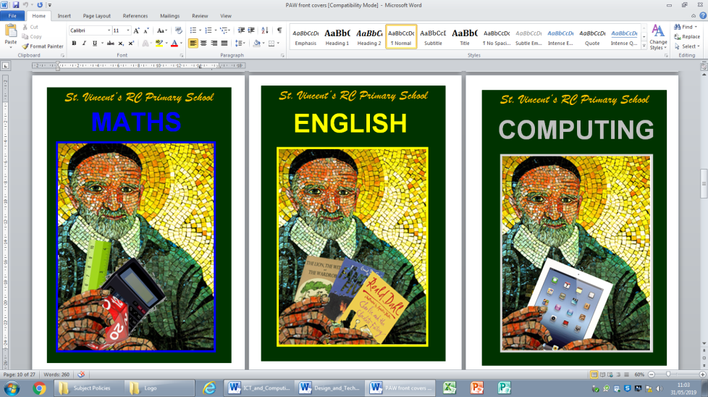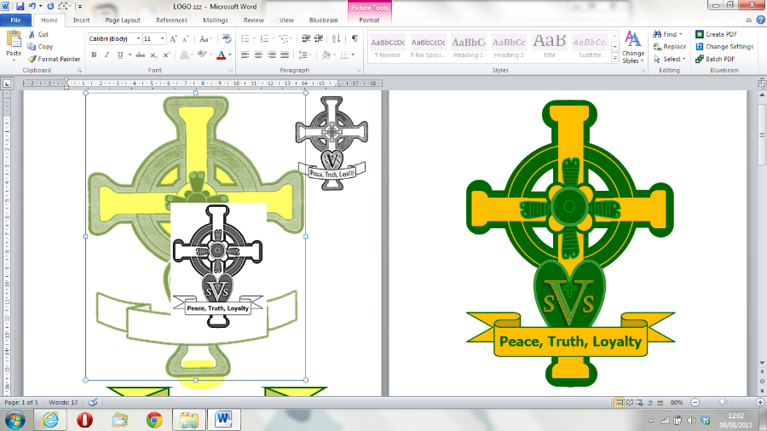

**Computing Policy**

# CONTENTS

1. Mission Statement 2
   1. Aims and Objectives 2
2. Approaches to Teaching and Learning 2
3. Resources 2
4. Learning Environment 3
5. Planning 3
6. Assessment 3
7. Cross Curricular Opportunities: 3
   1. Reading, writing, communication and maths 3
   2. Foundation subjects 3
   3. Spiritual, Moral, Social and Cultural 3
8. Enhancing the Curriculum: 4
9. Inclusion: 4
   1. Special Educational Needs and Disability and English as an Additional 4

Language

* 1. Gifted and Talented 4

1. Health and Safety and Safeguarding 4
   1. Rules for Internet use 5
   2. Maintenance of ICT system security 5
2. Roles and Responsibilities: 5
   1. ICT Leaders 5
   2. ICT Technician(s) and Network Manager 5

11 Policy Review 5

**This policy should be read in conjunction with the *E-Safety Policy and Acceptable Use Policy* and the following:** Assessment Policy. Health and Safety Policy, Equality and Community Cohesion Policy, Homework Policy, Safeguarding and Child Protection Policy and Special Educational Needs and Disability Policy

# Other documents that support the teaching and learning of ICT:

National Curriculum for Computing

Development Matters (for the Early Years Foundation Stage)

Documentation to support curriculum planning e.g. Hamilton Trust

**Throughout this policy ‘parents’ denotes those with parental responsibility.** Within this Policy, Information and Communication Technology is abbreviated to ICT.

# Mission Statement

Through teaching ICT and computing, St. Vincent’s Catholic Primary School equips children to participate in a rapidly changing world where work and leisure activities are increasingly transformed by technology. ICT is an effective teaching and learning tool to ensure high standards of pupil attainment across the curriculum, and provides children with lifelong learning skills. Children are taught how to use the Internet and email safely, both in school and outside the school environment. In addition, the School is committed to the use of ICT to promote efficient working practices and management of data. At St. Vincent’s, we enable children to find, explore, analyse, challenge, exchange and present information. Within the Curriculum implemented in 2014, children will also use computer science to analyse and solve problems in computational terms.

# Aims and Objectives

St. Vincent’s Catholic Primary School aims to enable children to:

* understand and apply the fundamental principles and concepts of computer science, including abstraction, logic, algorithms and data representation;
* analyse problems in computational terms and write computer programs to solve such problems;
* develop ICT capability in finding, selecting and using information;
* use ICT for effective and appropriate communication;
* apply the use of hardware and software to a range of situations involving information;
* apply their ICT skills and knowledge to their learning in other areas;
* use their ICT skills to develop their language and communication skills;
* explore their attitudes towards ICT and its value to them and society in general. For example, to learn about issues of security, confidentiality and accuracy.

# Approaches to Teaching and Learning

ICT and computing skills are taught both within dedicated ICT lessons once a week and within other curriculum subjects; using the ICT suite or other resources (see below). Teachers ensure meaningful contexts for the teaching of skills and, where relevant, these link to the cross-curricular topic being studied.

# Resources

The School has a fully equipped and networked ICT suite with 31 PCs and an interactive touch screen. Each classroom has at least one computer so children and staff are also able to log-on to the network from these as well as being equipped with interactive touch screens. Internet use is a part of the statutory curriculum and a necessary tool for staff and pupils. There is access to the Internet within the classroom and the ICT Suites: wireless access is available throughout the school.

All year groups will have subject specific ICT resources for teaching and learning. The School subscribes to Espresso, Espresso Coding, Letter Join, Times-table Rock Stars and 2-Simple. Other software and hardware is chosen to support age-appropriate development of skills including portable resources, such as cameras, voice recorders and iPads. There are 60 IPads stored in 2 trollies containing 30 tablets. One is located in the resource room and the other in the ICT suite.

The School liaises with parents via Teachers2Parents and 2Simple’s Evidence Me. These are email services that are used by teachers and office staff to communicate with parents with the aim of having an increasingly paperless system of communication.

All computers are networked and access to the server is limited to the technicians from Mercu IT Solutions. Any problems with hardware and software in school are reported to Mercu IT Solutions.

# Learning Environment

The School’s ICT suite enables whole classes to work together (in pairs or individually). As a teaching and learning tool, ICT is used across all areas of the School’s indoor and outdoor learning environment. The school’s trolley of 30 iPads of which there are 2 sets is used for classroom ICT activities, e.g. topic research.

# Planning

Specific planning for ICT (and computing from September 2014) using the School’s schemes of work is undertaken in the form of unit and weekly plans, which use assessment information to ensure that lessons meet the needs of all children both in subject knowledge and skill is included. As ICT is taught across the Curriculum, ICT is also integrated into planning for core and foundation subjects (see section 7 below). E-Safety is also planned for within the Curriculum (see E-Safety Policy).

# Assessment

There are many opportunities within ICT and computing for children’s on-going self-assessment as they seek solutions to problems, edit and self-correct their work. Children are assessed at the end of each unit of work by teachers through the use of ‘What do you know now?’ documents.

# Cross Curricular Opportunities

# Reading, writing, communication and maths

Communication skills are a key part of the ICT and can be applied across the curriculum as well as outside school. Access to ICT across the curriculum is always in conjunction with the School’s E- Safety Policy.

The use of ICT is fully integrated into planning for Literacy and Maths. Each class has an interactive touchscreen and most lessons across the curriculum are built around Notebooks, PowerPoints, websites and interactive activities that are shown on them.

In Literacy, children learn how to edit and revise text. They have the opportunity to develop their writing skills by communicating with people over the Internet using their safe personal email and they are able to join in discussions with other children throughout the world. They learn how to improve the presentation of their work by using desk-top publishing software. Film clips are used to stimulate writing across the year groups using the interactive whiteboards in each classroom.

In Maths, many ICT activities build upon the mathematical skills of the children. Children use ICT to collect data, make predictions, analyse results, and present information graphically. There are also activities that enable children to acquire and practice measuring techniques involving positive and negative numbers and decimal places. Children also use ICT to practise their computational skills and as an assessment tool.

# Foundation subjects

Children use ICT to research new topics, carry out interactive experiments, work through simulations, watch videos and film clips, and record audio and visual presentations.

Pupils develop research skills, safe use of search engines and become more discerning regarding the information they encounter. They are taught to decide what information is appropriate for their work. The children begin to investigate the quality and plausibility of the information they gather as well as learning to amend, edit and present work in a variety of ways depending on the purpose of the task and the audience.

# Spiritual, Moral, Social and Cultural

Through the discussion of moral issues related to electronic communication, children develop a view about the use and misuse of ICT, and they also gain a knowledge and understanding of the interdependence of people around the world.

# Enhancing the curriculum

Many children have access to ICT equipment at home, whilst others do not. The number of children who do not have access to ICT at home is monitored and after school/lunchtime access is provided

e.g. Homework clubs for Upper Key Stage 2. Some pupils are loaned individual devices from school.

# Inclusion

Classes at St. Vincent’s have children with widely differing ICT abilities and experience. ICT hardware and software also provide useful tools both to help overcome barriers and improve access for children with SEND or EAL and to enable more able, gifted and talented children to be challenged further.

# Special Educational Needs and Disability and English as an Additional Language

In planning lessons, teachers identify the learning goals for the majority of children and consideration is given to modifying the task, or providing peer or adult support, for children with language or learning needs.

Teachers will liaise with the SENDco on the use of ICT to improve such children’s access to the curriculum. Certain pupils with physical or communication difficulties have their own equipment for use across the curriculum, which may be specially adapted.

# Gifted and Talented

A small proportion of children exhibit particular gifts and talents in ICT and often need to be challenged through extension and enrichment activities. Gifted and talented children benefit from the use of software that offers opportunities to ask questions, solve problems and investigate ideas further.

# Health and Safety and Safeguarding

Safeguarding children is of the highest priority and this includes safe use of the Internet and other technologies. **This section should be read in conjunction with the School’s E-Safety Policy.**

At St. Vincent’s, all ICT equipment, along with other electrical items, is regularly checked under Portable Appliance Testing (PAT) guidelines.

All members of staff who work with children on computers are required to observe safety regulations. In particular they should ensure that

* equipment is sited on a solid surface if computer trolleys are not provided in the room;
* the siting of equipment does not interfere with free movement around the room and that there are no trailing cables;
* mains sockets are not overloaded and that extension leads, where used, are secured to the classroom wall. Extension leads must not trail across the classroom floor;
* computers are not sited near to: water supply, radiators, sand trays;
* computers are kept out of direct sunlight, as this makes the screen difficult to read and can cause overheating;
* staff are aware of the location and type of fire extinguishers;
* food and drink are kept away from ICT hardware and software;
* children are aware of the safety issues surrounding the use of electrical equipment;
* faulty or broken equipment is not used and is reported to the ICT Leader;
* children who are particularly sensitive to the flicker from monitors are watched carefully. A list of children who suffer from epilepsy is circulated to all staff;
* children are supervised at all times when using a computer;
* all staff are aware of, and have read, the E-Safety Policy;
* all teachers have received training on e-safety;

# Rules for Internet use

Rules for Internet use are posted in all rooms where computers are used. Pupils are informed that Internet use will be monitored. Children are taught responsible and safe use procedures with regard to Internet access.

# Maintenance of ICT system security

The School ICT system is reviewed regularly by our provider: virus protection is installed and updated regularly and the system is scanned every evening for potential viruses.

Each child is able to access the network by using a generic class login. The St. Vincent’s network is managed and maintained by technicians through our BBCET Mercu IT Solutions SLA.

# Roles and Responsibilities

# ICT Leader

The School acknowledges that the leadership and management of ICT is a significant role and therefore this role is shared between the Headteacher and an experienced member of staff: one of whom also acts as E-Safety Coordinator. ICT Leaders have responsibility to:

* plan replacement and upgrade of equipment on a rolling programme in conjunction with Governors;
* ensure the effective management of the School’s ICT network via Mercu IT Solutions;
* manage the work of the ICT technicians (see below);
* maintain a software library and manage the use of licences and agreements for software and online resources such as Espresso;
* liaise with colleagues regarding the evaluation and purchase of new hardware and software;
* organise repairs to hardware and purchase of replacements and consumables.

# ICT Technician(s) and Network Manager

The ICT technician’s role is defined by the Service Level Agreement with BBCET. The service provided also includes management of the network and advice as to infrastructure and upgrades. Regular responsibilities include:

* ensuring hardware and software is functioning efficiently and any faults are rectified, where possible;
* arranging repairs to hardware and purchase of replacements and consumables as instructed by the ICT Leader and Head Teacher;
* assisting with the set-up of new systems and hardware;
* liaising with other Mercu IT Solutions technicians and implementing BBCET-wide strategy for improvements to the Service;
* adding new users to the server;
* working closely with ICT Leaders and providing training and advice to them and to other staff members as appropriate;
* working through problems logged on the help desk software and giving feedback to the ICT Leaders.

# Policy Review

This Policy will be reviewed according to the cycle agreed by the governors’ Curriculum and Achievement Committee for curriculum policies.