**ST. VINCENT’S CATHOLIC PRIMARY SCHOOL**

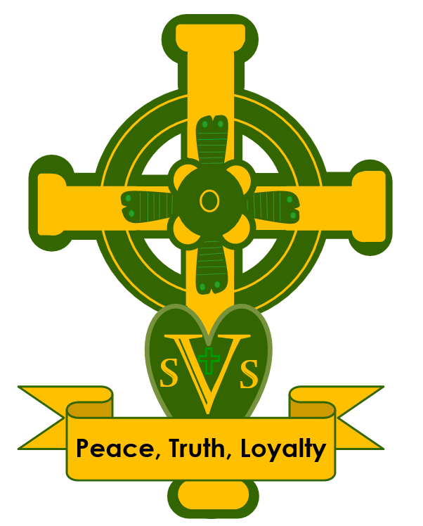

**ART & DESIGN POLICY**

Date reviewed: July 2025

Date of next review: July 2026

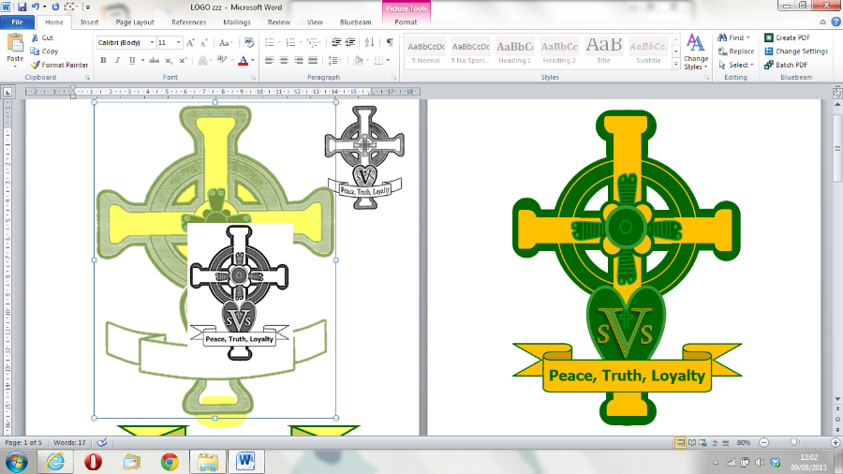

**Art and Design Policy**

# CONTENTS

1. Mission Statement 2
   1. Aims and Objectives 2
2. Approaches to Teaching and Learning 2
3. Resources 2
   1. Art Resources Room 2
   2. Sketchbooks 2
   3. Educational visits 3
4. Learning Environment 3
5. Planning 3
6. Assessment 3
7. Cross Curricular Opportunities 3
8. Enhancing the Curriculum 4
9. Inclusion 4
   1. Special Education Needs and Disability 4
   2. Gifted and Talented 4
10. Health and Safety 4
11. Roles and Responsibilities 4
12. Policy Review 4

**This policy should be read in conjunction with the *Teaching and Learning Policy*, any related subject policies and the following:**

Assessment Policy Behaviour Policy

Special Educational Needs and Disability Policy

Health and Safety Policy

Safeguarding and Child Protection Policy

# Other documents that support the teaching and learning of Art and Design:

National Curriculum for Art and Design

Development Matters (for the Early Years Foundation Stage) Documentation to support curriculum planning e.g. Hamilton Trust

# Throughout this policy ‘parents’ denotes those with parental responsibility.

# Mission Statement

Art and design is a fundamental part of the curriculum at St. Vincent’s as it allows children to explore their experience of the world and helps to stimulate their creativity and imagination. It also provides a medium for children to communicate their ideas and feelings about their personal and cultural worlds. Art and design provides a unique language for personal expression and communication and, as such, is an entitlement of every child.

Art, craft and design embody some of the highest forms of human creativity. A high-quality art and design education should engage, inspire and challenge pupils: equipping them with the knowledge and skills to experiment, invent and create their own works of art, craft and design. As pupils progress, they should be able to think critically and develop a more rigorous understanding of art and design. They should also know how art and design both reflect and shape our history, and contribute to the culture, creativity and wealth of our nation.

# Aims and Objectives

Our aim is to foster children’s understanding and enjoyment of art and design through a wide range of activities.

We aim to:

* + - encourage children to express their visual, imaginative and personal ideas of the world around them by providing tactile and sensory experiences;
    - develop children’s understanding of colour, form, texture and pattern and their ability to use materials and processes to communicate ideas, feelings and meanings;
    - develop the skills required to safely use a wide range of materials and techniques;
    - appreciate and evaluate the work of a range of artists and designers from their own and other cultures, both historical and present day;
    - develop an appropriate vocabulary to interpret works of art and design;
    - provide a changing environment that stimulates interest and enjoyment;
    - allow children to value and evaluate their own work and the work of others.

The national curriculum for art and design aims to ensure that all pupils:

* + - produce creative work, exploring their ideas and recording their experiences
    - become proficient in drawing, painting, sculpture and other art, craft and design techniques
    - evaluate and analyse creative works using the language of art, craft and design
    - know about great artists, craft makers and designers, and understand the historical and cultural development of their art forms.

# Approaches to Teaching and Learning

Please refer to the Teaching and Learning Policy.

# Resources

# Art Resources Room

All art resources, as well as materials to support curriculum planning, are located in the art resources cupboard. These are organised into boxes so that materials can be borrowed and returned easily. It is school policy that children are not allowed to enter or remain in this area without adult supervision. Books, postcards and images of artists’ work are stored in the library and in online planning folders.

# Sketchbooks

At St. Vincent’s, all children from Years 2-6 keep a sketchbook to help develop their drawing skills. Children are encouraged to use their sketchbooks for recording, exploring and storing visual and other information, for example, notes and selected materials which can be readily retrieved and used as reference. Children are also able to use their sketch books for reviewing and identifying progress and for developing ideas and skills as a unit of work develops.

There is a focus on practising and improving drawing skills in both Key Stages on a regular basis. This is so that children feel confident when producing working drawings and, as a result, learn to accept that it is good practice to rework drawings without the need for an eraser. Children are challenged to draw from observation, imagination and experience, using their sketchbooks where appropriate. They are also given the opportunity to draw for different purposes e.g. to explore ideas, to explain ideas to themselves and others and to record information about what has been observed.

# Educational visits

Children have the opportunity to develop their first hand observation and drawing skills through a variety of educational visits outside school. Children are also able to experience artists’ work first hand through exhibition and museum trips and through workshops in these settings.

# Learning Environment

Please refer to the Teaching and Learning Policy.

# Planning

To be read in conjunction with the Teaching and Learning Policy.

In Years 1-6, art and design is taught through half-termly topics. The long-term curriculum plan maps the art topics studied in each year group and units are chosen and adapted to ensure cross-curricular links, e.g. Y3 concurrently learn about coal mining in history and drawing with charcoal and chalk in art

We recognise that there are children of widely different artistic abilities in all classes, so we plan suitable learning opportunities for all children by matching the challenge of the task to the ability of the child. We achieve this in a variety of ways by:

* setting common tasks which are open-ended and can have a variety of responses;
* setting tasks of increasing difficulty (not all children complete all tasks);
* providing resources of different complexity depending on the ability of the child.

# Assessment

There are many opportunities within ICT and computing for children’s on-going self-assessment as they seek solutions to problems, edit and self-correct their work. Children are assessed at the end of each unit of work by teachers through the use of ‘What do you know now?’ documents.

# Cross Curricular Opportunities

* 1. **Reading, writing, communication, maths and computing**

The visual medium of art and design supports language development, reading and writing, and frequently accompanies it via illustration, and such links provide incidental opportunities for practising drawing and/or design skills. Where used for the purposes of teaching art and developing skills further, links are made more explicit.

When appropriate, computing is used as a medium in art and design, incorporating a variety of computer applications. Photographs are also manipulated to produce artwork using multimedia.

# Foundation subjects

Artworks are often used as a primary source to develop understanding within other subjects e.g. portraits of historical figures, religious art. Appreciation of the work of these artists is often used as a stimulus for children’s own artwork as well as written work, music and drama.

# Spiritual, Moral, Social and Cultural development (SMSC)

Through art and design children have the opportunity to consider their own attitudes and values in relation to images and artefacts and learn to challenge assumptions, stereotypes and prejudice in visual and other forms. They are encouraged to respect their own and others' work and learn how to offer and receive constructive feedback and praise. Appreciating art can be a moving and even spiritual experience: contributing to children’s spiritual, moral and cultural development

# Inclusion

To be read in conjunction with the Teaching and Learning Policy.

# Special Educational Needs and Disability

Art and Design provides a variety of opportunities and contexts for children to succeed and can help develop children’s self-esteem. As a subject, it offers the possibility of success at different levels and teachers should identify, in their planning, suitable resources and differentiated activities. In cases of physical or sensory disability, the school will endeavour to provide suitable equipment and resources to allow as full access to the subject area as possible. Teaching support staff may work with individuals if they would otherwise have particular difficulty in accessing this subject alongside their peers. For some children, resources may need to be adapted to enable them to participate.

# Gifted and Talented

We recognise that some children have a special ability in art which may or may not be linked to ability in other curriculum areas. Where appropriate, art planning for each unit includes extension activities to provide challenges for these identified children. Enrichment activities, such as workshops by artists, may be specifically targeted at children with particular talent in art.

# Health and Safety

To be read in conjunction with the Health and Safety Policy.

* Staff have a responsibility for the health and safety of children, of other members of staff and of themselves.
* Children should always be taught the safe use of tools and care of equipment.
* All tools and practical equipment in the classroom and from the art resources room should be kept in good condition, stored safely and be well organised. Glass containers must not be used.
* All paints, crayons and glues issued in school are non-toxic. Before using any other items teachers must check the labels carefully and if in doubt, check with the art subject leader.
* Glue-guns and paper trimmers are used **only under supervision** once rules have been established.
* Stanley knives and wire cutters are to be used only in Years 5 and 6 and in groups of no more than can be adequately supervised by the teacher. Steel rulers and a suitable cutting surface must be used.
* Staple guns, spray paints and fixative should only be used by adults when children are not present. The latter should be used in a well-ventilated space according to instructions.
* All equipment will be thoroughly cleaned after use.

# Roles and Responsibilities

Please refer to the Teaching and Learning Policy.

# Policy Review

This policy will be reviewed according to the cycle agreed by the governors’ Curriculum and Achievement Committee for curriculum policies